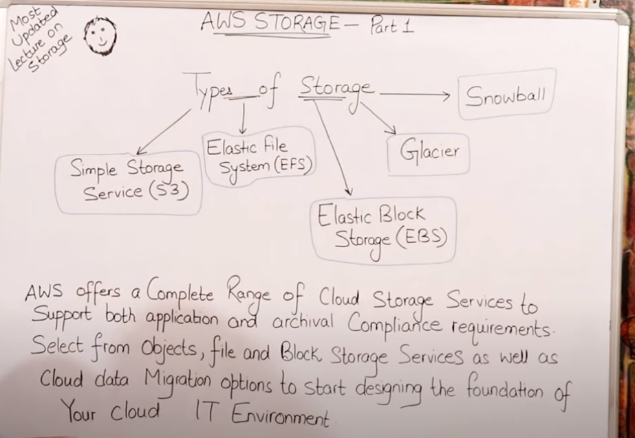

Block storage:



Object Storage:

In AWS, EBS (Elastic Block Store) and object storage services like Amazon S3 (Simple Storage Service) serve different purposes and have distinct characteristics:

Amazon EBS (Elastic Block Store):

Purpose: EBS provides block-level storage volumes for use with EC2 instances. It is used for storing data that requires frequent updates and low-latency access, such as databases and operating systems.

Performance: EBS volumes offer different performance options (e.g., General Purpose SSD, Provisioned IOPS SSD, Throughput Optimized HDD) to meet varying performance requirements.

Persistence: EBS volumes persist independently from the life of an EC2 instance. They can be detached from one instance and attached to another.

Snapshots: EBS volumes can be backed up using snapshots, which are incremental backups that capture the changes made to the volume over time.

Amazon S3 (Simple Storage Service):

Purpose: S3 is an object storage service that is used for storing and retrieving large amounts of unstructured data, such as photos, videos, and documents. It is designed for scalability, durability, and high availability.

Performance: S3 is optimized for high-throughput performance and is capable of handling large volumes of data with low latency.

Durability: S3 is designed for 99.999999999% (11 9's) durability of objects over a given year, making it highly reliable for storing critical data.

Object Storage: S3 stores data as objects, which consist of a file, metadata, and a unique identifier. Objects are organized into buckets, and each object is identified by a key.

Similarities:

Both EBS and S3 are storage services provided by AWS.

Both offer durability and high availability of data.

Both support encryption to protect data at rest.

Differences:

Use Case: EBS is used for block storage and is typically attached to EC2 instances for use as primary storage. S3 is used for object storage and is suitable for storing large amounts of unstructured data.

Performance: EBS offers different performance options and is optimized for low-latency access. S3 is optimized for high-throughput performance and is designed for storing and retrieving large objects.

Persistence: EBS volumes persist independently from EC2 instances and can be moved between instances. S3 objects are stored independently and are accessed via HTTP or API calls.

Backup: EBS volumes can be backed up using snapshots. S3 objects can be versioned and replicated across multiple regions for backup and disaster recovery.

In summary, EBS is ideal for use cases that require low-latency access to block storage, while S3 is suitable for storing large amounts of unstructured data with high durability and scalability requirements.

S3 Simple storage service:





  
